2016-17 GHS Cheerleaders

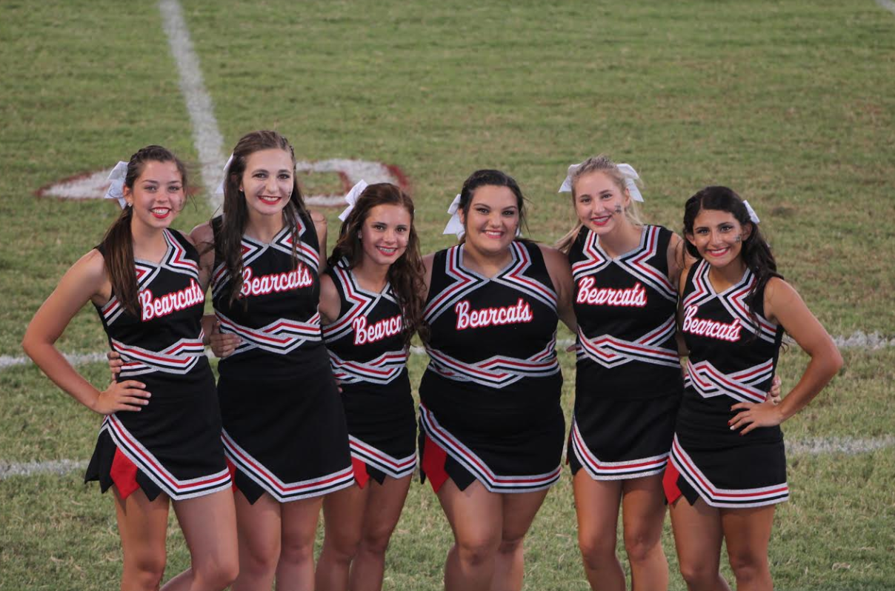
Photo by: Julie Coody

Members: Matti Clemmer (Jr.), Monique Rodriguez (Jr.), Addie Coody (So.), Jalee Spradlin (So.), Camee Witt (So.), & Laylee Ramirez (So.)
Coach: Malinda Rodriguez

Page Created by: Addie Coody

